**Análisis y diseño II**

**Laboratorio III**

**Ejemplo[1]**

Let’s see how a layered architecture was used to solve a real problem.

Amaze is a project management software company. Their product is sold globally with a monthly pay-per-user model and widely known among the project management community for being easy to use and able to operate on many different devices (PCs, Notebooks, laptops, tablets, iPhones, iPads, and Android phones).

**What’s the Business Problem?**

The business problem is very straightforward: Amaze must work on any popular device on the market and be able to support future devices. There must be only one version of the software for all devices. No special cases, no exceptions allowed.

So to sum up:

* We know that users have different devices.
* There must be only one software application because the company wants to have low software maintenance costs.
* When new device launches, we do not want to change the whole software product.

**What's the Solution?**

Now that we’ve walked through the thought process, let’s see the detailed architecture diagram:

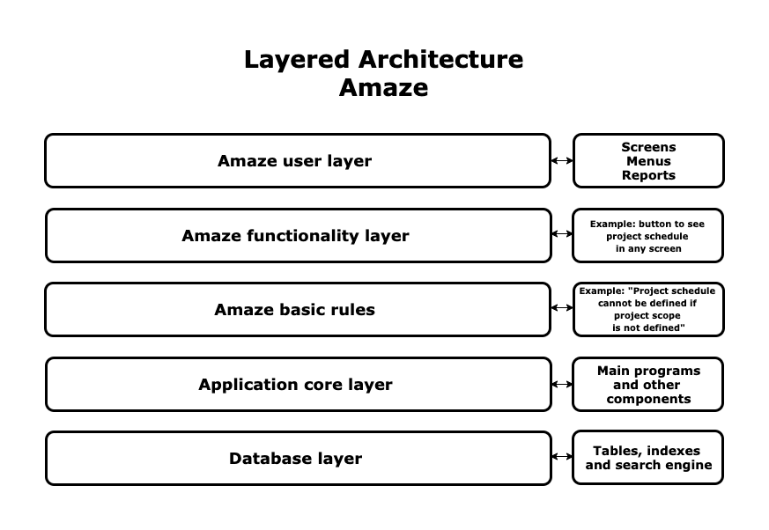Amaze layered architecture

In our case, the Amaze basic rules layer is critical. This layer contains rules that determine the behavior of the whole application, such as, "You can create a project schedule only if the project scope is defined." The product's intelligence is in this layer: all special features that come from decades of experience in projects are developed there. The application core layer will be the most significant part of the application code.

**Reto**

Now that you’ve seen one solution see if you can apply what you’ve learned to another!

**Context**: You have been a software architect at a major insurance company in your country for the last four years. Your boss is Carla, the chief information officer (CIO) of the company. The company has offices in 24 cities and more than 2,100 employees.

**Your Mission**: You have been asked to develop a software system for managing new insurance policies for your clients’ staff in different industries (finance, manufacturing, technology, engineering, etc.). Each industry has different customs and requirements for managing employee benefits.

Here are some key questions you should ask yourself:

* How are you going to handle different industry requirements in one single system?
* What do all policies in all industries have in common, regardless of the industry, customer, or insured goods?
* How could you separate common requirements for all industries and specific requirements for each industry?
* Who is going to define the business rules for each industry?
* Can you produce an architecture diagram for this business setting?

**Recordar**

|  |  |  |  |  |
| --- | --- | --- | --- | --- |
| **Architecture Model** | **Description** | **Advantages** | **Disadvantages** | **When to use it** |
| **Layered** | Software operates in layers that allow each component to be independent of the rest. | Encapsulation of hardware, software, and functionality.  If a layer is changed, the rest of the layers stay the same. | For small applications, many layers create a performance problem and are very difficult to maintain. | Only for big applications. |

1. Fuente de referencia: OpenClassrooms (2023). **Design Your Software Architecture Using Industry-Standard Patterns.** https://openclassrooms.com/en/courses/6397806-design-your-software-architecture-using-industry-standard-patterns/6896176-layered-architecture